Purpose:
To ensure accurate and timely deliveries, all WMSHL hospital and offsite members shall follow the same procedure for online ordering, adjusting linen orders, and/or cancelling an order.
Policy:
- Order Deadline:
- Based upon the day and time of a member’s delivery, an “ORDER DEADLINE” is assigned.
- All orders must be placed online by the deadline.
- Any cancellation, addition, or change to an order placed after the deadline will result in a late adjustment fee (SEE FEE SCHEDULE).

- Missing Orders:
- In the event an order is not received by the order deadline, the member will receive ½ (50%) of the stated Par Level for all linen items.

- Placing Orders in Advance:
  - If necessary, in the event of a planned absence, members may place an order(s) up to six days in advance.
  - If the order exceeds six days in advance, members shall call the Linen Coordinator and request that an order(s) be generated.

- Permanent or Long-Term Changes to Par Levels:
- For any additions or changes to your par level inventory that will be long-term or permanent, members must contact the client relations manager. The CRM will provide you with a timeline for those adjustments and an updated par level inventory.

- One-time Order Changes:
- For one-time order requests, members must contact the linen coordinator by phone, fax, or email to adjust the delivery.
- Change requests must be made prior to the order deadline.

- Placing an Emergency Order:
- Faxing or calling in orders is to be done in the event of an emergency only. (i.e. a member’s computer system is down, ordering in advance for a special circumstance or holiday).
- If you need to fax an order, the member must notify the linen coordinator prior to the order deadline, so that confirmation of the order can be sent.
- In the event of a faxing error, and the member did not notify WMSHL prior to the order deadline, the member is responsible for any fees due to special deliveries, or adjustment fees, etc. (SEE FEE SCHEDULE).

ONLINE ORDERING INSTRUCTIONS
LINEN MASTER
To place your order, please use the following link: https://wmshl-ui.linenmaster.net
Login homepage
- Enter your username and password to sign in. NOTE: If your password is less than 6 characters/digits, please let us know so we can update this and provide a new password. The new interface requires at least 6 characters/digits or it will not allow access for security reasons.
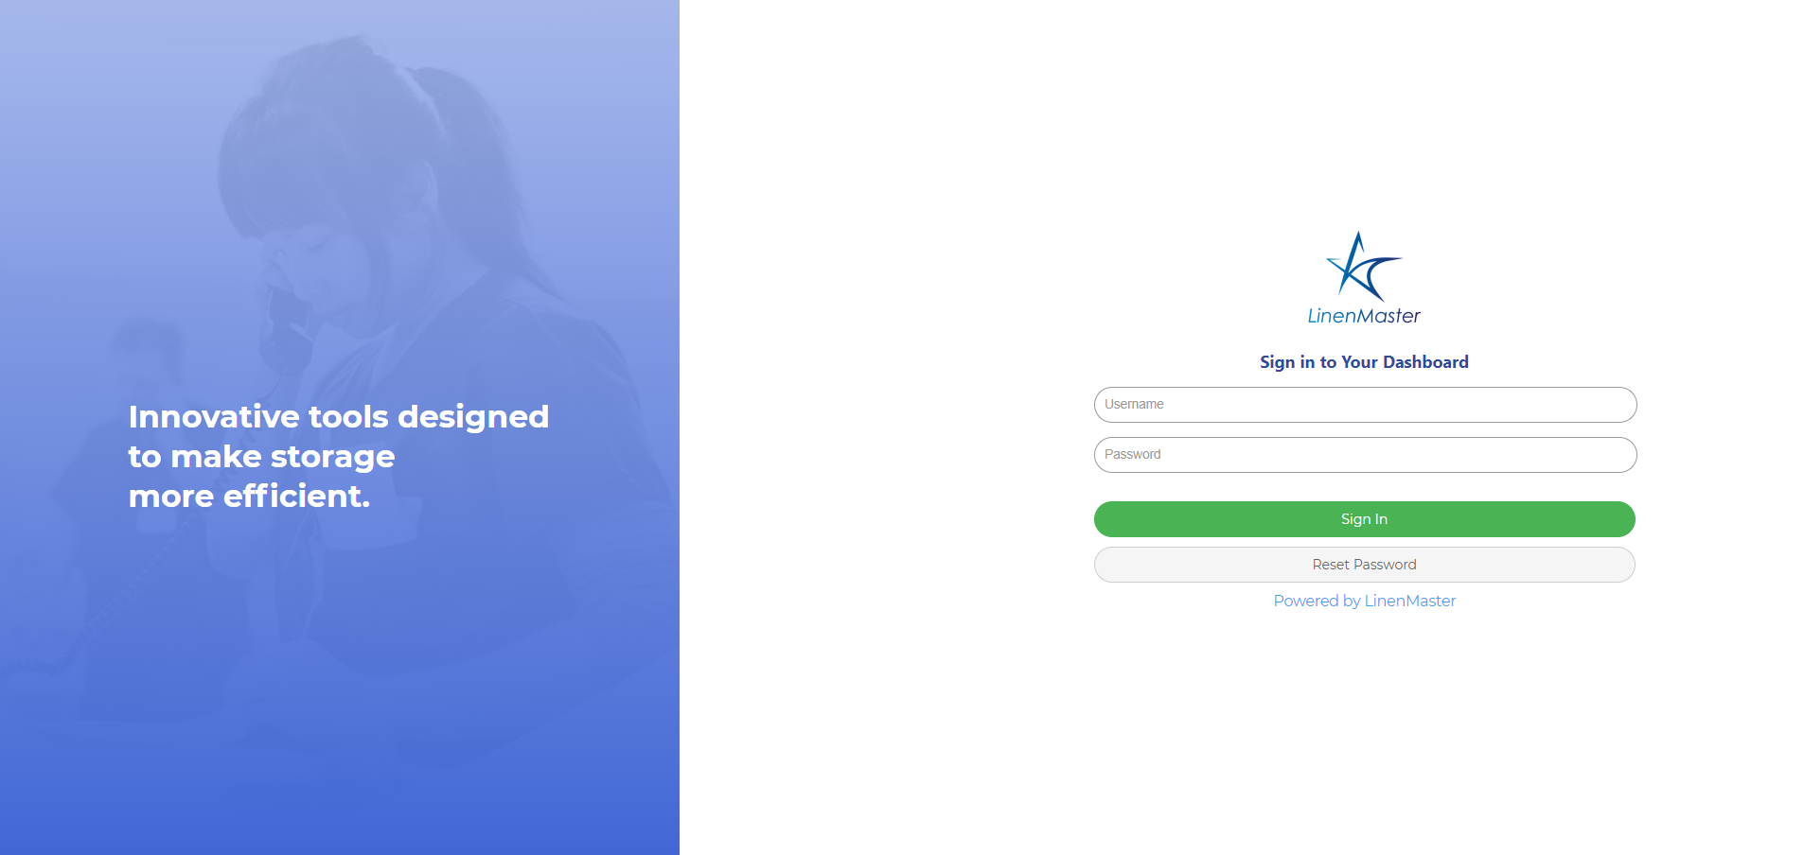

- Click on the “deliveries” tab in the top left corner. NOTE: DISREGARD the error message in yellow.
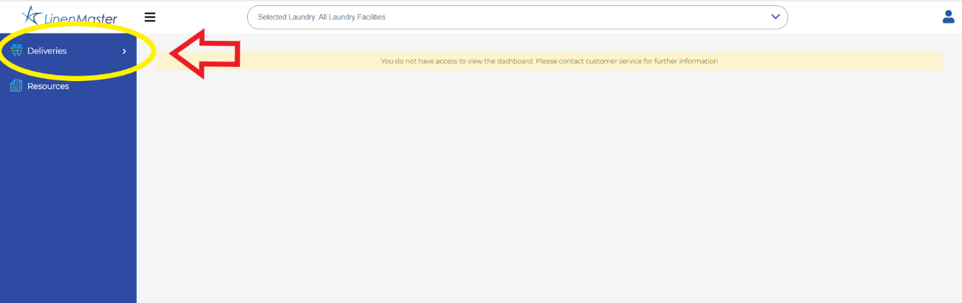
- Click on the “Customer Requirements” tab underneath deliveries. 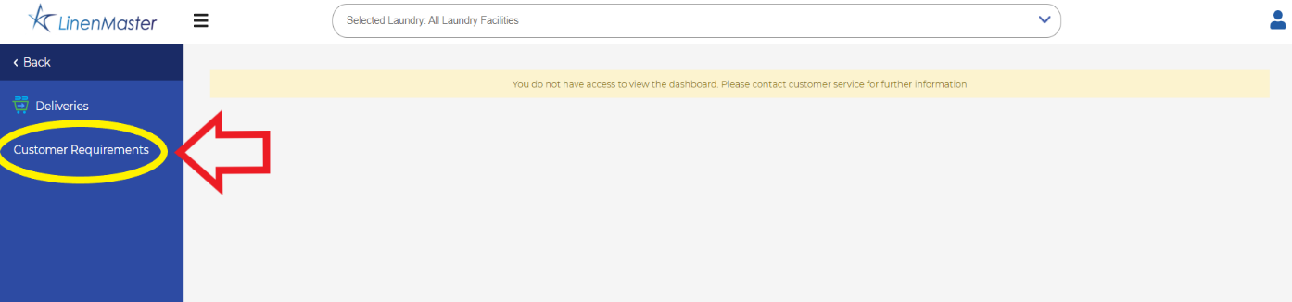

- In the “Delivery Date Range” sections, you will select the actual date of delivery in both spots (see example in photo), then select “apply filters”.
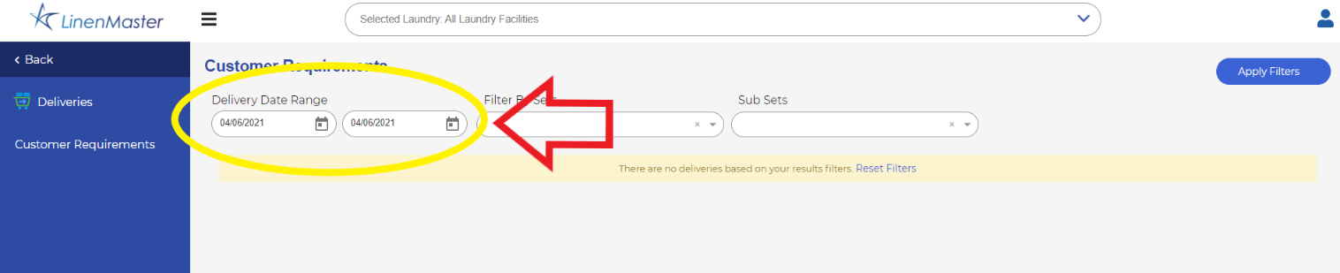

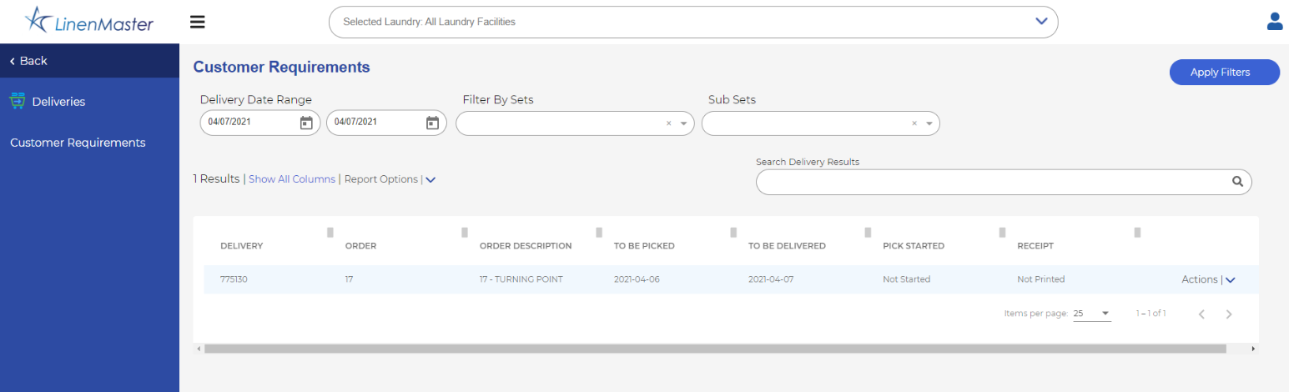
- Click on the arrow next to “Actions” on the far right of your screen. Then select “View Items” from the pop-up window. NOTE: Disregard “to be picked and to be delivered date” columns-this is for office use only and does not always reflect your actual delivery date.

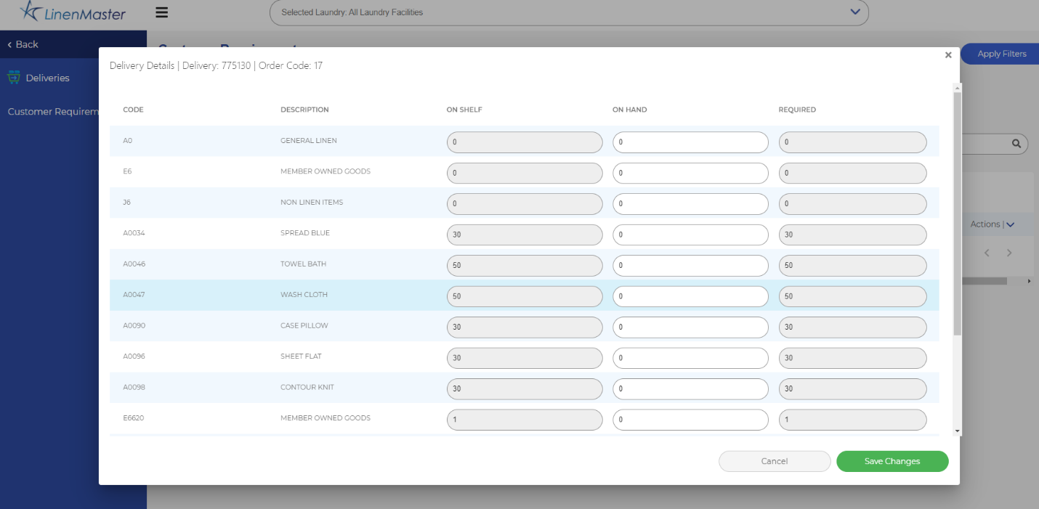
- You may now enter your numbers in the “ON HAND” column in the center. After you enter your on-hand counts, select the “Save Changes” button in the bottom right-hand corner. You will automatically be redirected back to the main page.

Checking to ensure order saved: from the main login page, select the “actions” tab, and then select “view order”. You should see your numbers in there. If it shows all zeros in the on hand column, your order was not saved and needs to be submitted again.
To View or Email your order from the main login page, click the arrow next to “REPORT OPTIONS” on the main page and select either “view” or “email” report.
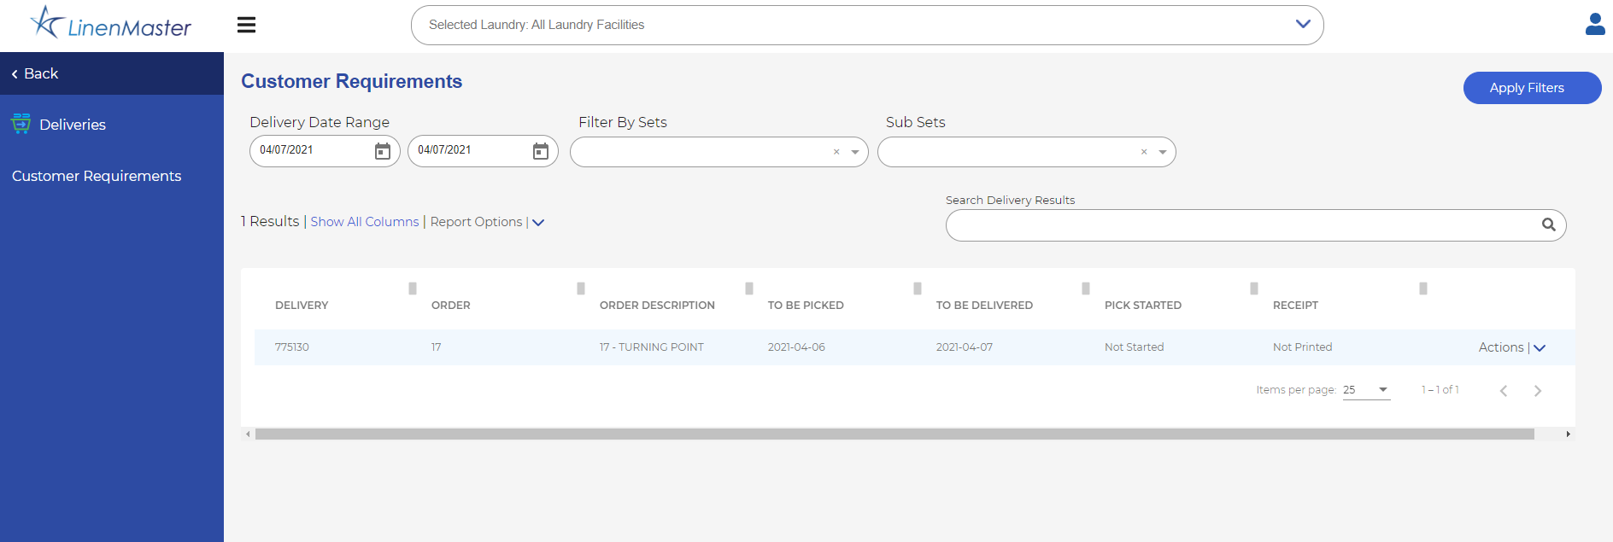

Your order is now submitted and you can close the web browser.

