POLICY:
WMSHL agrees to process member owned doctor coats that are not part of the laundry cooperative pooled linen. The doctor coats are owned, purchased, and replaced by the respective WMSHL member. WMSHL is not responsible for loss or damage. WMSHL is responsible for labeling each doctor coat to include a barcode to be scanned by WMSHL., and to return the doctor coats within seven (7) days. The barcode label ensures the item is tracked through processing and returned to the proper owner.
Barcodes:
- Date the coat was scanned in at WMSHL.
- Date the coat was delivered back to the respective member account.
- Date the coat was put into service.
Repair and Mending:
- Doctor Coats are not property of WMSHL and therefore repair/mending is not performed.
- During processing, the doctor coat is inspected for defects. If damage is found, the doctor coat is sent back with a “RECEIVED DAMAGED” label (see example):
REPAIR LABEL:

PROCEDURE:

- PROCEDURE FOR ESTABLISHING DOCTOR COAT SERVICE:
Please contact WMSHL @ 616-784-9050, to speak with a Client Relations Manager. The Client Relations Manager will review policy and procedures and forward the forms to be completed prior to this service commencing.

- SENDING NEW COATS FOR PROCESSING
- To establish new service, members are required to acknowledge the doctor coat policy and procedure by signing and returning this policy to the Client Relations Manager, along with the New Doctor Coat Form (Attachment A):
- A separate form must be completed for each provider.
- If a provider practices in more than one location, one form must be completed for each location for the provider.
- The CRM will contact the member to confirm a service start date. Please do not send the doctor coats until a start date has been provided.
- Upon receiving a start date, place the coat(s) in a clear plastic bag with a Processing Slip (see example below)
- Clear plastic bags can be obtained from your delivery driver.
- Processing Slips are obtained from your delivery driver.
PROCESSING SLIP:
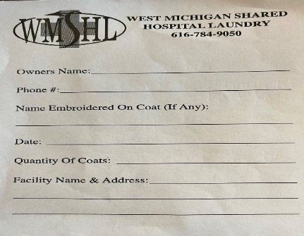
- Designate a location to leave doctor coat(s) in your soil linen room.
- Please communicate the designated location to your delivery driver.
- Place the bag(s) in the designated location for the WMSHL driver to pick up.
- Do not place in the blue soiled bags.
- Please contact WMSHL if you would like to purchase a soil linen hamper to be utilized solely for doctor coats.
- Upon receiving, WMSHL will label each doctor coat with a permanent bar-coded label inside the coat, at the neckline (see example): LABEL WITH BARCODE:
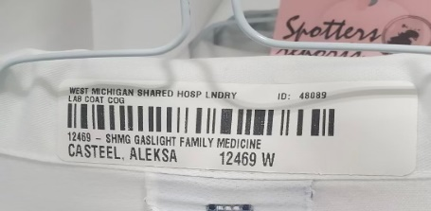

- ROUTINELY SENDING BARCODED DOCTOR COATS FOR PROCESSING:
- Place coats in a clear plastic bag, with the Processing Slip.
- Place the bagged coats, in the designated location for the WMSHL driver to pick up.
- Do not place in the blue soiled bags.

- ADDING A NEW PROVIDER:
- Complete the New Doctor Coat Form (Attachment A) and send to drcoats@wmshl.org or fax to 616-784-7800.
- A separate form must be completed for each provider.
- If a provider practices in more than one location, one form must be completed for each location for the provider.
- You will be contacted to confirm a service start date. Please do not send the doctor coats until a start date has been provided.

- CHANGING PROVIDER LOCATION, or ADDING A LOCATION FOR A PROVIDER:
If a provider moves to a different location, or if the provider begins practice at an additional location, please follow the steps below to ensure the provider receives the right coat, at the right location.
- Prior to sending doctor coats to be processed/labeled, completely fill out the CHANGE Doctor Coat Form (Attachment B):
- A separate form must be completed for each provider.
- If a provider practices in more than one location, one form must be completed for each location for the provider.
- Email the completed CHANGE Doctor Coat Form to drcoats@wmshl.org, or Fax to 616-784-7800.
- Upon receiving, WMSHL re-labels the coat(s).

- RETURN DELIVERY FOR DOCTOR COATS:
Each doctor coat is placed on a hanger and covered with a clear plastic bag. Doctor coats are delivered separate, however, alongside general linen.
- Please designate a location for CLEAN doctor coats to be returned.
- Please communicate the clean designated location with the WMSHL driver.
- It is the responsibility of the member to ensure the doctor coats are delivered to the provider.
- MISSING DOCTOR COATS:
- In the event a doctor coat is assumed missing, please go to www.wmshl.org and complete a lost and found report. If the doctor coat is located, WMSHL will contact the account. It is the responsibility of the account contact to advise WMSHL with changes to contact information. Please email drcoats@wmshl.org to report a change in contact information.
- Unclaimed doctor coats are placed in “lost and found”. The doctor coat “lost and found report” is sent monthly.
- Unclaimed doctor coats are held for ninety (90) days and are then disposed of appropriately.
- WMSHL is not responsible for missing or lost doctor coats.

- RETIRING DOCTOR COATS:
- If the doctor coat(s) are no longer in need of servicing by WMSHL, please complete and send the CHANGE Doctor Coat Form (Attachment B), to drcoats@wmshl.org (indicating the coat(s) should be removed from the system).
___________________________________________________________________________________________________________

POLICY ACKNOWLEDGMENT

Member Account Name: ________________________________________________ Memer Account Number: ______________

Please Print Member Name and Title: ___________________________________________________________________________

Contact Signature: _____________________________________________________ Date: ________________

-----------------------------------------------------------------------------------------------------------------------------------------------------------------------------------

For internal use only:

Received by: ______________________________________________________ Date: _________________

